2303A51581
Batch-10
LAB ASSIGNMENT-6.3
Task 1: Classes (Student Class)
#PROMPT
Create a Python class named Student. Add attributes: name, roll number, and branch using __init__. Create a method display_details() to print all student information. Create sample objects and display their details.
#CODE
class Student:
def __init__(self, name, roll_number, branch):
self.name = name
self.roll_number = roll_number
self.branch = branch

def display_details(self):
print(f"Name: {self.name}")
print(f"Roll Number: {self.roll_number}")
print(f"Branch: {self.branch}")

# Example usage
if __name__ == "__main__":
student1 = Student("Alice", "101", "Computer Science")
student2 = Student("Bob", "102", "Mechanical Engineering")

print("Student 1 Details:")
student1.display_details()
print("\nStudent 2 Details:")
student2.display_details()
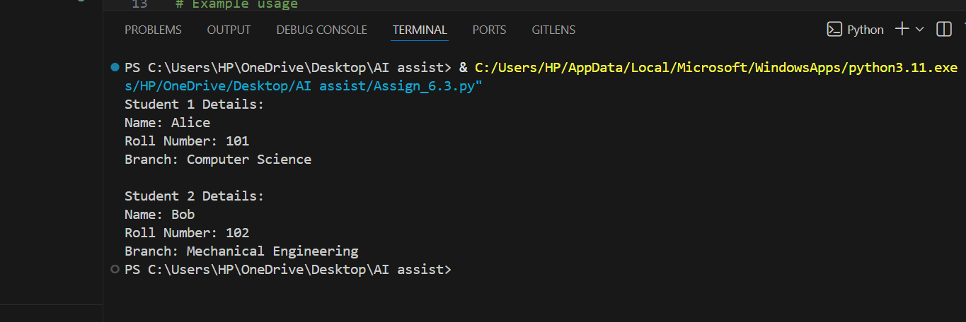
#OUTPUT

#ANALYSIS
The AI-generated code correctly defines a Student class with a constructor to initialize student attributes using self. The display_details() method cleanly prints the student’s name, roll number, and branch. The code is simple, readable, and follows proper object-oriented programming practices, making it suitable for beginner-level student management tasks.

Task 2: Loops (Multiples of a Number)
#PROMPT
Write a Python function that takes a number as input and prints the first 10 multiples of that number using a loop. Include sample input and output execution.
#CODE
def print_multiples(number, count=10):
print(f"First {count} multiples of {number}:")
for i in range(1, count + 1):
print(number * i)

# Example usage
if __name__ == "__main__":
num = int(input("Enter a number to find its multiples: "))
print_multiples(num)
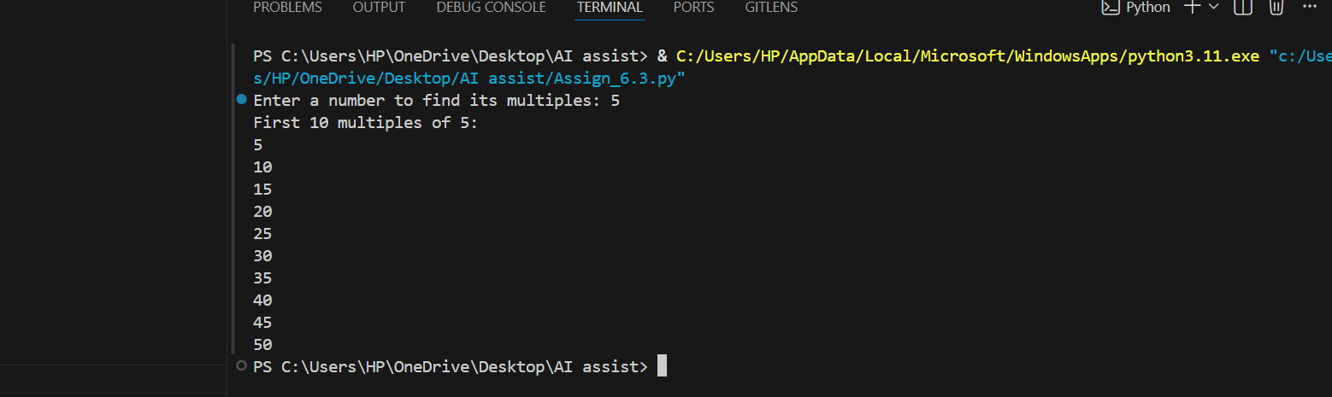
#OUTPUT

#ANALYSIS
This program uses a function to print the first 10 multiples of a number entered by the user. It uses a for loop to repeat the multiplication from 1 to 10. The code is simple, easy to read, and shows how loops help avoid writing the same calculation again and again.
Task 3: Conditional Statements (Age Classification)
#PROMPT
Write a Python function that takes age as input and classifies it into child, teenager, adult, or senior using nested if-elif-else conditions.
#CODE
def classify_age_group(age):
if age < 0:
return "Invalid age"
elif age <= 12:
return "Child"
elif age <= 19:
return "Teen"
elif age <= 59:
return "Adult"
else:
return "Senior"
# Example usage
if __name__ == "__main__":
age = int(input("Enter age to classify: "))
age_group = classify_age_group(age)
print(f"The age group is: {age_group}")
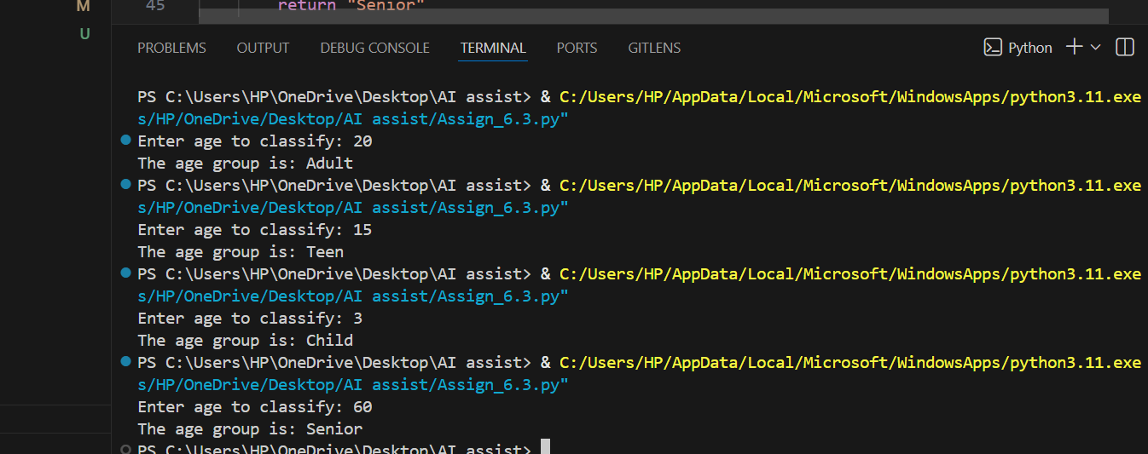
#OUTPUT
#ANALYSIS
This program uses conditional statements to classify a person’s age into different groups. It checks the age step by step using if, elif, and else to decide whether the person is a child, teen, adult, or senior. The logic is clear and handles invalid input properly, making the program both correct and easy to understand.
Task 4: For and While Loops (Sum of First n Numbers)
#PROMPT
Write a Python function that returns the sum of the first n natural numbers using a for loop. Include input handling and output display.
#CODE
def sum_to_n(n):
total = 0
for i in range(1, n + 1):
total += i
return total
# Example usage
if __name__ == "__main__":
n = int(input("Enter a positive integer n to calculate the sum of first n numbers: "))
if n > 0:
result = sum_to_n(n)
print(f"The sum of the first {n} numbers is: {result}")
else:
print("Please enter a positive integer.")
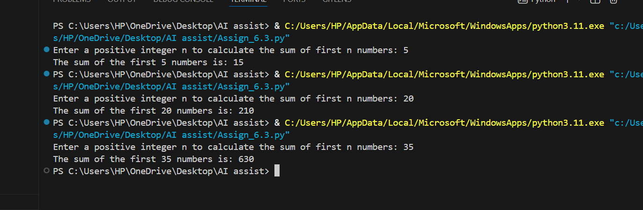
#OUTPUT
#ANALYSIS
This program uses a function and a for loop to add numbers from 1 to n. The loop runs n times and keeps adding each number to a total variable. The logic is simple, easy to understand, and correctly calculates the sum of the first n natural numbers.
Task 5: Classes (Bank Account Class)
#PROMPT
Generate a Python class named Bank Account with attributes for account holder and balance. Include methods to deposit money, withdraw money with balance check, and display current balance. Use if-else conditions. Also show sample usage.
#CODE
class BankAccount:
def __init__(self, account_holder, balance=0): # FIXED __init__
self.account_holder = account_holder
self.balance = balance

def deposit(self, amount):
if amount > 0:
self.balance += amount
print(f"Deposited ${amount:.2f}. New balance: ${self.balance:.2f}")
else:
print("Deposit amount must be positive.")

def withdraw(self, amount):
if amount > self.balance:
print("Insufficient funds.")
elif amount <= 0:
print("Withdrawal amount must be positive.")
else:
self.balance -= amount
print(f"Withdrew ${amount:.2f}. New balance: ${self.balance:.2f}")

def check_balance(self):
print(f"Current balance for {self.account_holder}: ${self.balance:.2f}")

# Example usage
if __name__ == "__main__": # FIXED __name__
account = BankAccount("John Doe", 1000)
account.check_balance()
account.deposit(500)
account.withdraw(200)
account.check_balance()
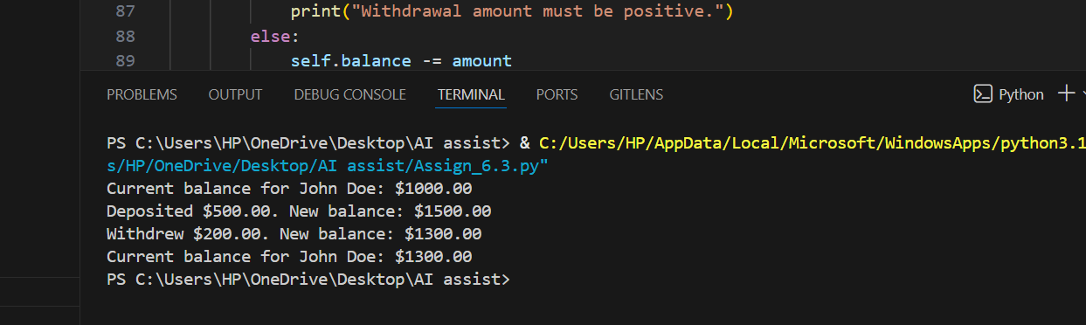
#OUTPUT
#ANALYSIS
The AI-generated code correctly uses a class with attributes and methods. It applies if-else conditions to prevent invalid deposits and withdrawals. The logic is clear, easy to read, and follows object-oriented principles properly. The use of initialization and self performs that each object maintains its own data.

